

Project Name: Digital Health Eco-System

Branch E-DAC Mar-2022

Documentation On

**“Digital Health Eco-System”**

E-DAC Mar-2022

**Guided By: Snehal Somvanshi**

Submitted By :

**Group No: 12**

* **Hrishikesh U. Bodke 220343020036**
* **Mrunal P. Mandhare 220343020052**
* **Pankaj R. Ushir 220343020062**
* **Prajwal P. Pande 220343020071**

**Table of Contents**

**1. Introduction 4**

1.1 Document Purpose **4**

1.2 Project Background **4**

1.3 Aim & Objectives **4**

**2. Business Requirements Overview**…………………………………………………………**5**

**3.Functional Requirements** **5-6**

3.1 Admin Module

3.2 Patient Module

3.3 Hospital Module

3.4 External service provider Module…………………………………………………………………………………..

**4.** **Non-Functional Requirement………………………………………………………………6**

**5. Use Case Diagram 7**

5.1 Admin **7**

5.2 Patient **8**

5.3 Hospital **9**

5.4 External service provider……………………………………………………………………………………………….**10**

**6. Database Design 11**

1 Patient **11**

2 Hospital………………………………………………………………………………….**.11**

3 Ambulance……………………………………………………………………………….**12**

4 Ambulance Order………………………………………………………………………..**13**

5 Login/User………………………………………………………………………………………..**13**

**7. E-R Diagram………………………………………………………………………………………14**

**8. Snapshots 15**

**9. Conclusion 21**

**10. Future Scope** ………………………………………………………………………………………**21**

**List of Figures**

**Use Case Diagrams 17**

Fig 1 Admin 7

Fig 2 Patient 8

Fig 3 Hospital 9

Fig 4 External Service Providers…………………………………………………………...10

Fig 5 ER Diagram ….14

1. **Introduction:**
   1. **Document Purpose:**

This document communicates the business requirements and scope for developing

Digital Health Eco-System. The scope of this document is to define the functional and non functional requirements, business rules and other constraints requirements.

## Project Background:

Medical Emergency, especially in this pandemic has become an issue that almost all of the families of patients had to face. But by using the latest technologies this problem can be solved. The main reason for this problem is, hospitals do not have proper portal for managing bed availability, required medicines, and other emergency facilities. So it is always difficult for the patient to reach appropriate hospital. Therefore we have tried to address this problem with the help of our project where the focus is to make sure that every patient gets a bed and related required emergency facilities.

## Aim & Objectives:

The main objective of our application is to provide an efficient and user-friendly bed availability system and related required emergency services and facilities. A community in which all people achieve their full potential for health and well-being across the lifespan. We work to be trusted by patients and creators of positive change. This system will provide easy information of all available hospitals, its facilities and external services like ambulance booking etc. This system will help any citizen in his/her in all panic situations.

1. **Business Requirements Overview:**

* Digital Health Ecosystem is the public web application.
* Digital Health Ecosystem will be opened to the global, but in the phase 1, the main target is in the India.
* There are mainly two types of user. One is the Patient and other is Hospital.
* Patient can search for the available beds of hospitals on the emergency basis and even the information about the hospital and its staff.
* Patient can search for the external service provider like ambulance, blood bank, equipment providers on emergency.
* Digital Health Ecosystem provides the functions which connect the patient and the hospital efficiently and quickly.
* Digital Health Ecosystem could be maintained by Administrator.

# Functional Requirements Overview:

Digital Health Ecosystem consists of four modules described as below.

1. Administrator Module
2. Patients / Needy people Module
3. Hospital Module
4. External service provider Module (Ambulance, Blood Bank, Equipment providers)
   1. **Administrator Module**

* Digital Health Ecosystem should provide all function to admin how to handle the System.
* He will edit changes according to the patient’s request.
* He is responsible to edit patient’s details, doctor details etc.

**3.2 Patients / Needy people Module**

* Patients who seeking for any emergency services can visit site and accordingly selects what they are exactly looking for .e.g. any appointment, specialist doctor visit, lab test etc.

# **3.3 Hospital Module**

* Hospitals can register their specialized services or equipment on our platform for better exposure through which they can reach out more and more audiences/patients.

**3.4 External service provider Module**

* Medical service provider from outside world can give / register their specialized services or equipment on our platform for better exposure through which they can reach out more and more audiences/patients.
* Some of the the external services are Ambulance service, Bloodbank service etc.

1. **Non-Functional Requirement:**

* The website should use professional design, look and feel and color scheme.
* Users will have no limitations for accessing the application through Internet. The portal being an internet application, it is difficult specify exact number of visitor or users. Hence we will target the system to support between 5 and 10 million users on launch of phase 1.
* Being a public website, the site must follow general usability guidelines for menus, navigation, colors, links and other actions provided on the screens.
* The system should be designed in such a manner that user will be able to complete tasks in minimum number of steps.

.

## 5. Use-Case Diagrams:-

**5.1 Admin:**

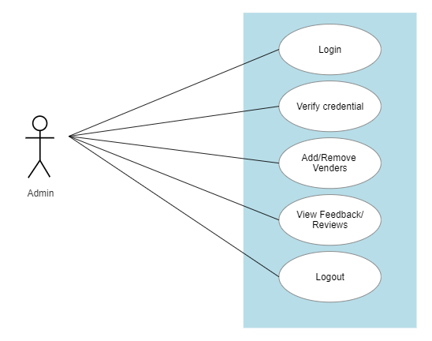

Fig. Use-Case Diagram for Admin

**5.2: Patient**

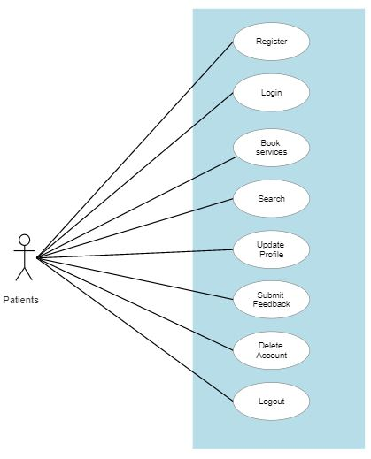

Fig. Use-Case Diagram for Patient

**5.3 Hospital:**  
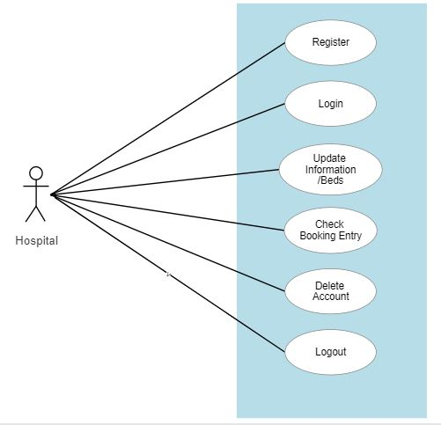

Fig. Use-Case Diagram for Hospital

**5.4 External Service Providers:**  
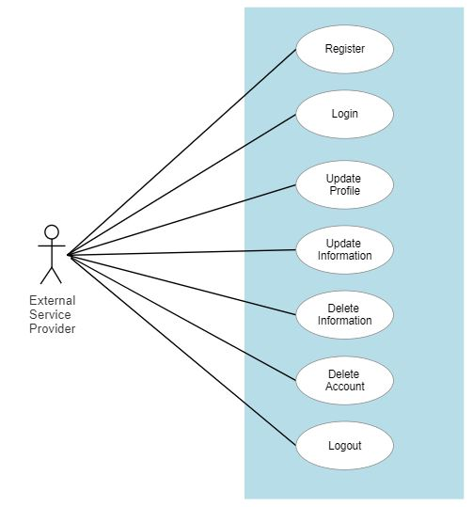

Fig. Use-Case Diagram for External Service Providers.

**6. Database Design:**

1. **Patient:**

|  |  |  |  |  |  |  |
| --- | --- | --- | --- | --- | --- | --- |
| **Field** | **Type** | **Null** | **Key** | **Default** | **Extra** | **Description** |
| pid | int | NO | PRI |  | auto_increment | Patient id |
| fname | varchar(50) | NO |  |  |  | First Name |
| lname | varchar(50) | NO |  |  |  | Last Name |
| mono | varchar(50) | NO | UNI |  |  | Mobile No of Patient |
| email | varchar(50) | YES |  |  |  | Email |
| adharno | bigint | YES | UNI |  |  | Adhar No of Patient |
| dob | varchar(50) | NO |  |  |  | Date Of Birth |
| gender | varchar(20) | NO |  |  |  | Gender Information |
| age | int | NO |  |  |  | Age of Patient |
| bloodgrp | varchar(20) | NO |  |  |  | Blood GRP Of Patient |
| ac_status | int | NO |  |  |  | Account is in Use or Not (soft delete) |
| pic | blob | YES |  |  |  | Profile pic of Patient |
| state | varchar(50) | NO |  |  |  | State of Patient |
| city | varchar(50) | NO |  |  |  | City of Patient |
| lid | int | NO | FK |  |  | LogiID |
| pincode | int | NO |  |  |  | Pincode of Patient |
| landmark | varchar(50) | NO |  |  |  | Landmark of Patient |

1. **Hospital:**

|  |  |  |  |  |  |  |
| --- | --- | --- | --- | --- | --- | --- |
| **Field** | **Type** | **Null** | **Key** | **Default** | **Extra** | **Description** |
| hid | int | NO | PRI |  | auto_increment | Hospital ID |
| hname | varchar(50) | NO |  |  |  | Hospital name |
| hregno | varchar(50) | NO | UNI |  |  | Hospital Reg No |
| hinfo | varchar(500) | NO |  |  |  | Hospital Information |
| genralbed | int | NO |  |  |  | No. Of General Beds |
| icubed | int | NO |  |  |  | No. Of ICU Beds |
| email | varchar(50) | NO |  |  |  | Email of Hospital |
| mono | varchar(50) | NO | UNI |  |  | Mobile No. Of Hospital |
| state | varchar(50) | NO |  |  |  | State of Hospital |
| city | varchar(50) | NO |  |  |  | City of Hospital |
| pincode | int | YES |  |  |  | Pincode of Hospital |
| landmark | varchar(50) | NO |  |  |  | Landmark of Hospital |
| website | varchar(50) | YES |  |  |  | Website of Hospital |
| himg | blob | YES |  |  |  | Profile Img of Hospital |
| genbedlastupdate | varchar(45) | NO |  |  |  | General bed Available/NotAv(0/1) |
| icubedlastupdate | varchar(45) | NO |  |  |  | ICU Bed Availbale/NotAv(0/1) |
| sc_status | varchar(45) | NO |  |  |  | Account is in Use or Not (soft delete) |

1. **Ambulance:**

|  |  |  |  |  |  |  |
| --- | --- | --- | --- | --- | --- | --- |
| **Field** | **Type** | **Null** | **Key** | **Default** | **Extra** | **Description** |
| aid | int | NO | PRI |  | auto_increment | Ambulance ID |
| drivername | varchar(50) | NO |  |  |  | Driver name of Ambulance |
| aregno | varchar(50) | NO | UNI |  |  | Ambulance Reg No |
| avehicalno | varchar(50) | NO | UNI |  |  | Ambulance RTO No. |
| email | varchar(50) | YES |  |  |  | Email of Ambulance |
| mono | varchar(50) | NO | UNI |  |  | Mobile No. of Ambulance |
| website | varchar(50) | YES |  |  |  | Website of Ambulance |
| state | varchar(50) | NO |  |  |  | State of Ambulance |
| city | varchar(50) | NO |  |  |  | City of Ambulance |
| pincode | int | NO |  |  |  | Pincode of Ambulance |
| landmark | varchar(50) | NO |  |  |  | Landmark of Ambulance |
| ac_status | varchar(45) | NO |  |  |  | Account is in Use or Not (soft delete) |
| availablestatus | varchar(45) | NO |  |  |  | Ambulance is Free or Not |

1. **Ambulance Order:**

|  |  |  |  |  |  |  |
| --- | --- | --- | --- | --- | --- | --- |
| **Field** | **Type** | **Null** | **Key** | **Default** | **Extra** | **Description** |
| aoid | int | NO | PRI |  | auto_increment | AmbulanceOrder Id |
| bookingid | int | YES | MUL |  |  | References to bid(Booking tbl) |
| ambulanceid | int | YES | MUL |  |  | Reference to aid(Ambulance tbl) |
| source | varchar(45) | NO |  |  |  | Source of Ambulance |
| destination | varchar(45) | NO |  |  |  | Destination of Ambulance |
| charges | varchar(45) | NO |  |  |  | Approximate charges of service |
| date | varchar(45) | NO |  |  |  | Date of Ordering |

1. **Login/User:**

|  |  |  |  |  |  |  |
| --- | --- | --- | --- | --- | --- | --- |
| **Field** | **Type** | **Null** | **Key** | **Default** | **Extra** | **Description** |
| lid | int | NO | PRI |  | auto_increment | LoginID |
| uname | varchar(50) | NO | UNI |  |  | User Names |
| password | varchar(50) | NO |  |  |  | Passwords |
| role | varchar(50) | YES |  |  |  | Roles (patient , ambulance etc) |

**7. ER Diagram:**

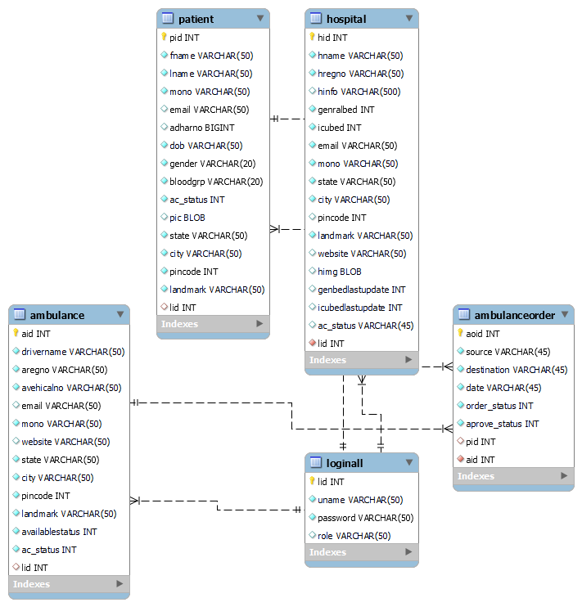

**8. Snapshots:**

**8.1 Home Page**

Following snapshot shows the Home page for Digital Health Eco-System.

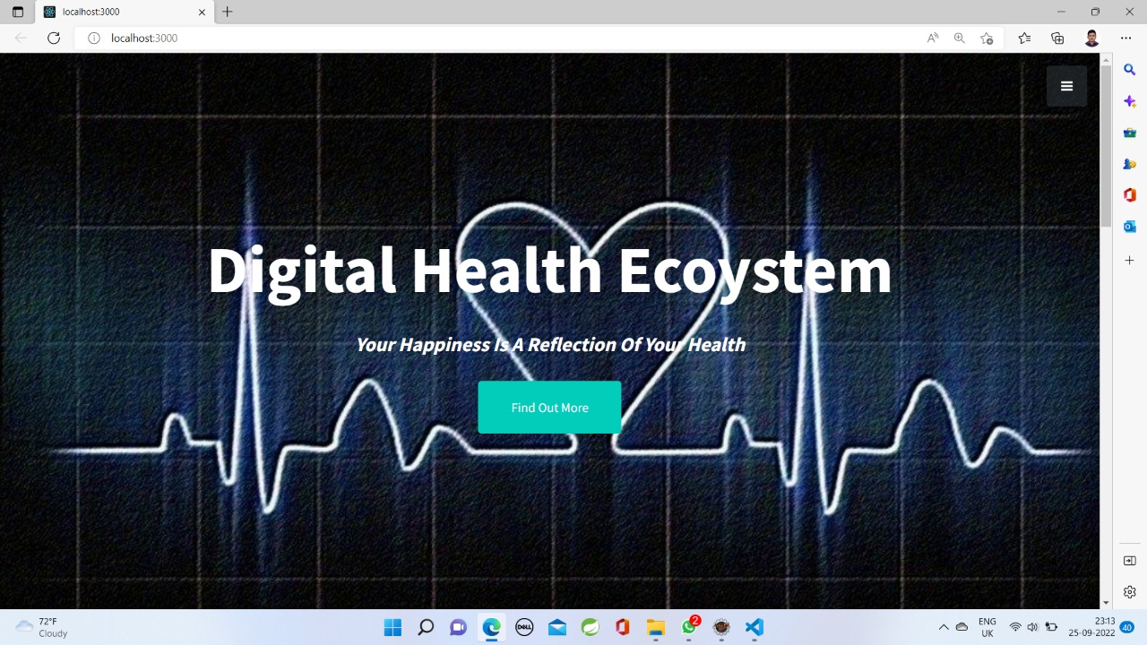

This home page contains the “Find Out More” Control.

It also contain a “Ham Burger Menu” which contains the following Controls:

🡪Login

🡪Signup

🡪About

🡪Services

🡪Contact

**8.2 About Us Page**

Following snapshot shows the About Us page for Digital Health Eco-System.

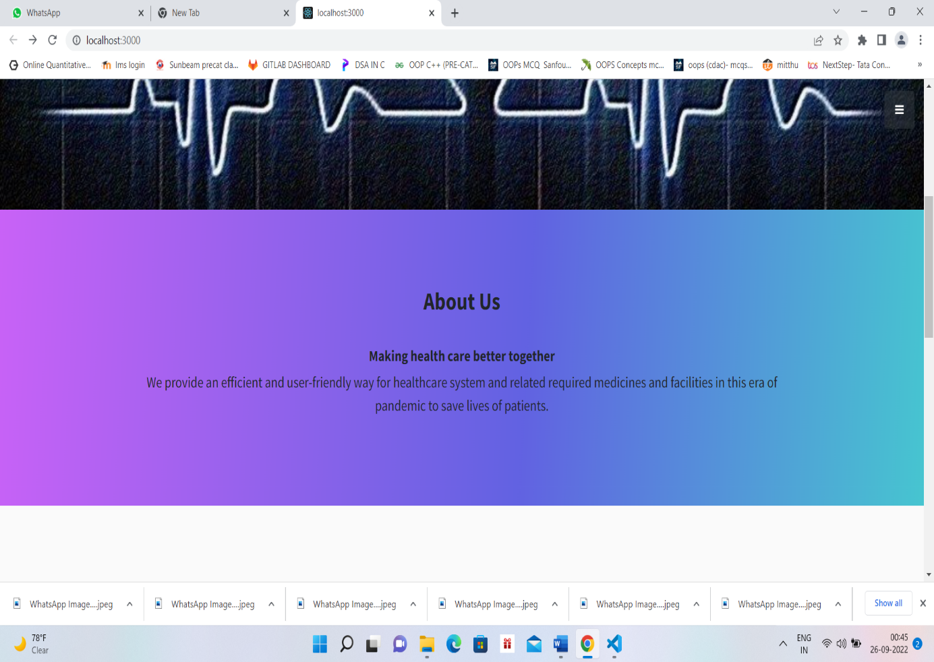

**8.3 Services Page**

Following snapshot shows the Services Page for Digital Health Eco-System.

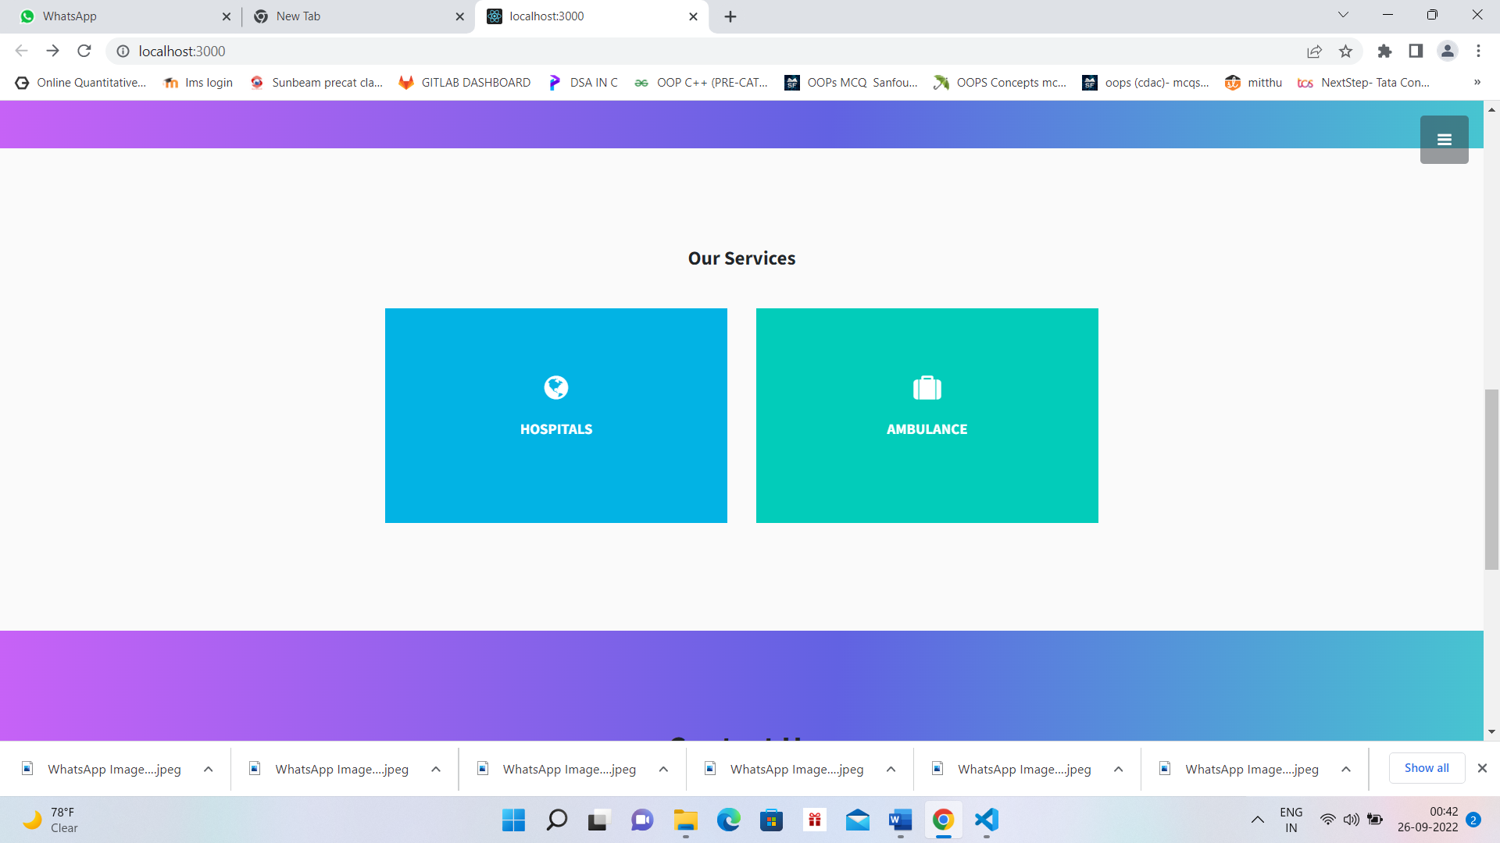

Our Service Page Shows two Services namely Hospital And Ambulance which are designed in the form of “Mouseover” and shows brief information about the services they provide.

**8.4 Contact Us Page**

Following snapshot shows the Contact Us for Digital Health Eco-System

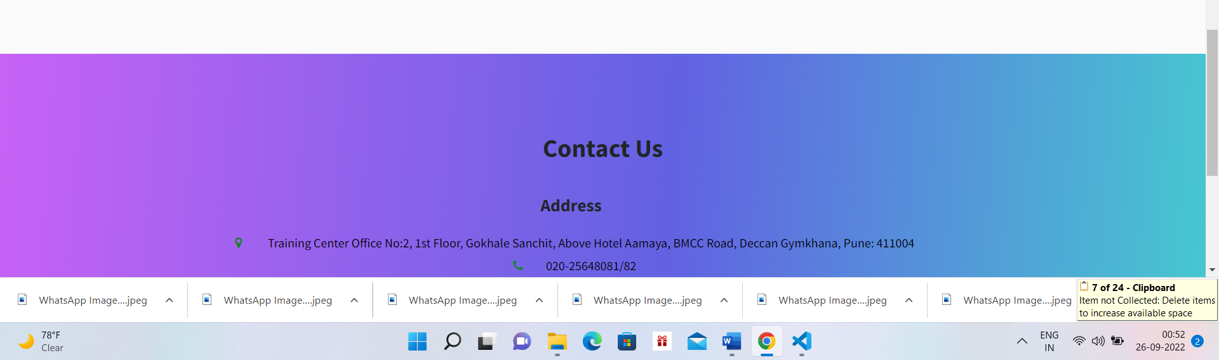

**8.5 Login Page**

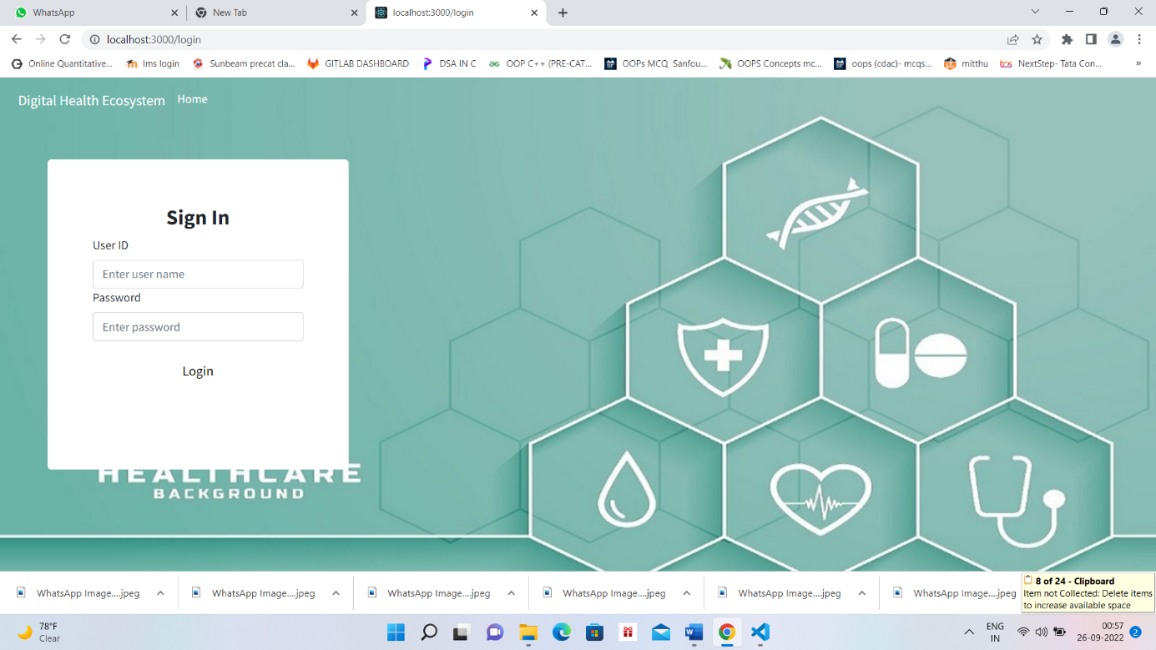

**8.6 Patient Signup Page**

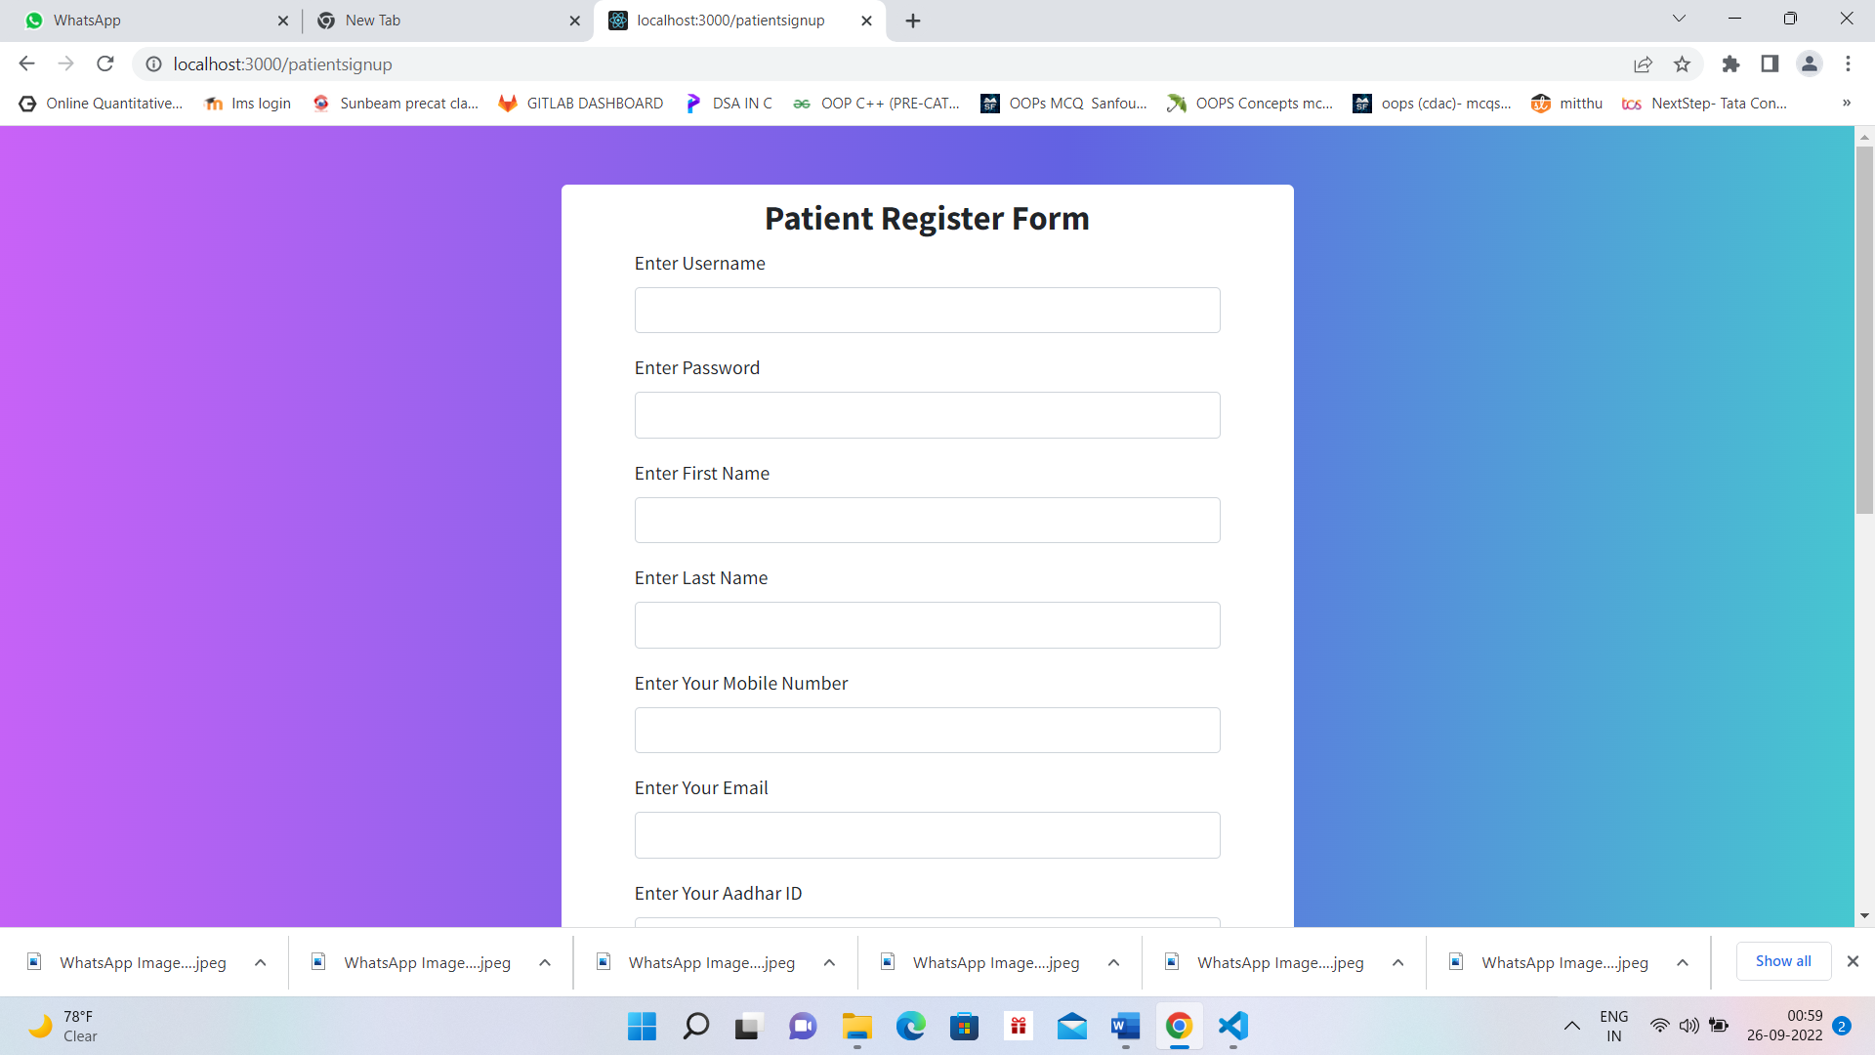

**8.7 Ambulance Signup Page**

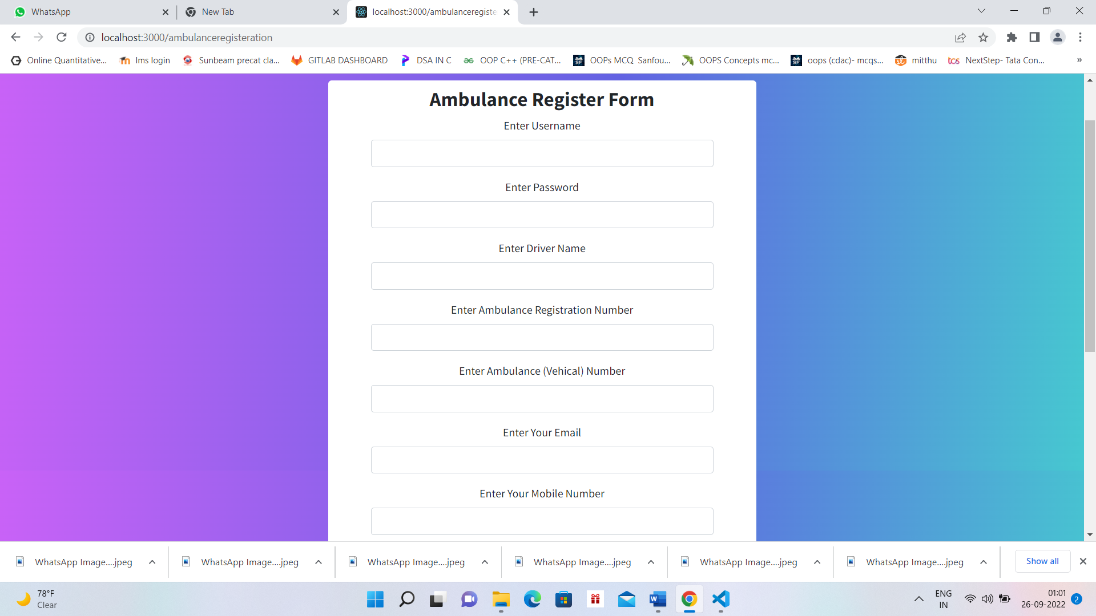

**8.8 Hospital Signup Page**

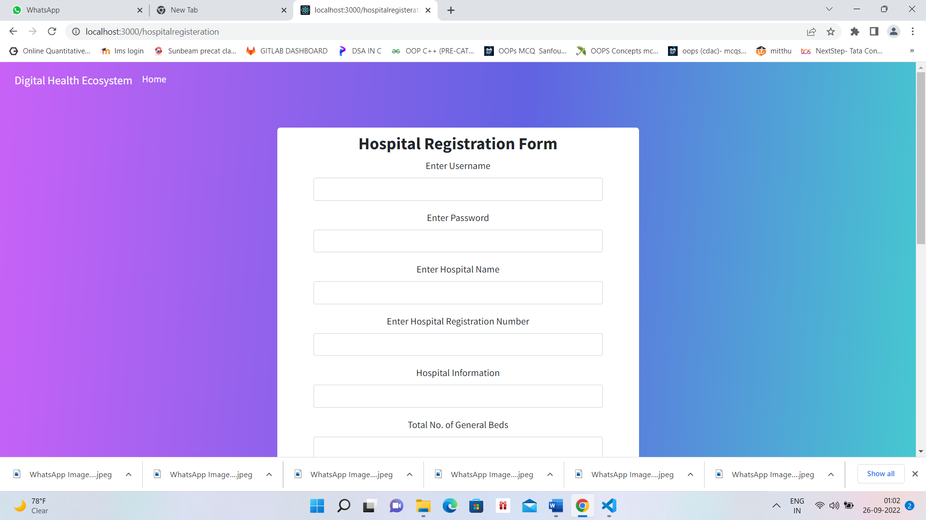

**9. Conclusion**

Digital Health Eco System provides a better efficient and user-friendly bed availability system and related required emergency services like ambulance booking and required medicinal and Hospital facilities like bed availability . We help people in achieving their full potential for health and well-being across the lifespan which results in bringing a positive change into the lives of people medically and supporting them in panic or emergency situations.

**10. Future Scope**

Digital Health Eco System has the scope for future development. As it’s been a whole eco system brought here altogether , it still has some volume left to contribute into a medical emergency sector of our health Eco-System. So, to keep the abstract of technical improvements and observing on-growing needs into this emergency sector The above written conclusion is just a initial conclusion and not yet concluded 100% because we are yet to update with some emergency requirements like Blood Bank Stock Availability and Bookings, Feedbacks etc.

This enhancements will be done efficiently and according to the varying needs of the people/users and it’ll be integrated with minimal modifications Thus our project is flexible and can be enhanced at any time with more advanced features in the future.